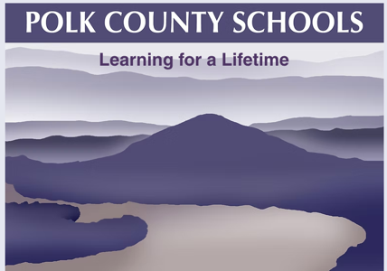
Polk County Schools
Protection of Pupil Rights Amendment (PPRA)

PPRA affords parents certain rights regarding our conduct of surveys, collection and use of information for marketing purposes, and certain physical exams. These include, but are not limited to, the right to:
Consent before students are required to submit to a survey that concerns one or more of the following protected areas ("protected information survey") if the survey is funded in whole or in part by a program of the U.S. Department of Education.
- Political affiliations or beliefs of the student or student’s parents
- Mental or psychological problems of the student or student’s family
- Sex behavior or attitudes
- Illegal, anti-social, self-incriminating, or demeaning behavior
- Critical appraisals of others with whom the respondents have close family relationships
- Legally recognized privileged relationships, such as with lawyers, doctors, or ministers
- Religious practices, affiliations, or beliefs of the student or parents
- Income, other than as required by law to determine program eligibility
Receive notice and an opportunity to opt a student out of the following:
- Any other protected information survey, regardless of funding
- Any non-emergency, invasive physical exam or screening required as a condition of attendance, administered by the school or its agent, and not necessary to protect the immediate health and safety of a student, except for hearing, vision, or scoliosis screenings, or any physical exam or screening permitted or required under State law
- Activities involving collection, disclosure, or use of personal information obtained from students for marketing or to sell or otherwise distribute the information to others
Inspect, upon request and before administration or use:
- Protected information surveys of students and surveys created by a third party;
- Instruments used to collect personal information from students for any of the above marketing, sales, or other distribution purposes
- Instructional material used as part of the educational curriculum
These rights transfer from a student’s parents to a student 18 years old or to an emancipated minor.
For surveys and activities scheduled during the school year, parents will be provided reasonable notification of the planned activities and surveys listed below and be provided an opportunity to opt their child out of such activities and surveys. Parents will also be provided an opportunity to review any pertinent surveys. Following is a list of the specific activities and surveys covered under this direct notification requirement:
- Collection, disclosure, or use of personal information collected from students for marketing, sales, or other distribution.
- Administration of any protected information survey not funded in whole or in part by ED.
- Any non-emergency, invasive physical examination or screening as described above.
Parents who believe their rights have been violated may file a complaint with:
Family Policy Compliance Office
U.S. Department of Education
400 Maryland Avenue, SW,
Washington, D.C. 20202-5920

